Dear Mr.BoneSaw your face smells like a chicken shawarma:   
A Clapback to Saudi Arabia’s Electronic Army  
  
Saeeda Saeed   
  
Hello:) My pseudonym is Saeeda Saeed, and I’m an e-activist from Saudi Arabia. This is the story of how I came to devise an Instant Meme Noise Generator that spews out nonsensical insults to the top 10 Saudi state-run Twitter accounts. In 2019, I came to the Netherlands to undergo my very first art residency. That summer, I bought myself a FlixBus ticket from Maastricht to Paris. As the bus stopped over at a gas station, I opened my backpack and pulled out several smartphones to test run my shady looking troll farm. I then noticed the bus driver walking towards me with a concerned look on his face. He asked, ‘Ma’am what are you up to? What are all those phones for?’ I took a deep breath, channeled all the artists that I’d been hanging out with over the last 6months and blurted out, ‘This is a performance art piece!’ Right then and there I witnessed his body language shift from fear and concern to fascination and curiosity as he warmly replied, ‘Oh how interesting! Where will this be exhibiting? Do you need any help setting up?’ I remember thinking, ‘woah I wonder what else could I get away with by contextualizing my activism within the arts?’ What would happen if I injected methods of play, performance, fiction and humor into my activism? Whilst humor has long been used as a tool against oppression, with the emergence of digital technologies memes have become renowned for their ability to perform criticism through humor and satire. This draws parallels to a Foucauldian understanding of ‘disqualified knowledges’ or the local popular knowledge in which criticism performs its work. In this essay, I reflect on the use of internet memes as a means to collectivize power, to shift the on-going political narrative, to drown out official state-run tweets, to vent and express frustration directly towards state institutions that have prosecuted, harassed and silenced critical voices within the Saudi authoritarian regime.

## The Rise of Hypernationalism in Saudi Arabia

Imagine an electronic dance music festival with DJ David Guetta remixing pro-regime patriotic songs: the crowd goes wild when the beat drops on the lyrics ‘LONG LIVE THE SALMANS.’

[1] Prior to gaining the nickname Mr.BoneSaw, the crown prince Mohammed Bin Salman—also known as MBS—was quick to gain the support of the Saudi transnational google generation aged 15 to 34 which make up 36.7% of the population.[2] Upon his anointment in April 2017, he led several successful reforms that vastly altered the socio-political atmosphere of the country. These include legislation that limits the power of the religious police, the removal of the ban on female driving in June 2018 and the weakening of the male guardianship system in 2019. Also in line with the rebranding of the state is the ‘Saudi Vision 2030’ campaign: an economic plan to increase public spending and reduce the country’s dependency on oil, which meansamplifying the entertainment and tourism sectors.

However, the very same millennial ruler who organized EDM festivals also knew the extent to which algorithmic feed based platforms like Twitter, Facebook and Youtube could be used as an instrument to monitor what the people were thinking and writing, and to use it as a tool to control and/or dampen the on-going political narrative. In November 2017, a new anti-terrorism law stated that simply 'retweeting’ anything that goes against the state, the establishment, or religion can be punishable by 1000 lashes and a 10-15 year jail sentence. The state then installed two Twitter moles that released IP addresses and contact details of more 6000 twitter accounts.[3] Soon after, Turki bin Abdul Aziz Al-Jasser was arrested and tortured to death in March 2018 for allegedly running a Twitter account called Kashkool, which exposed human rights violations by Saudi authorities. In May and August of 2018, several female activists were arrested and subjected to torture and sexual abuse during their detention.[4] Shortly after followed the murder and dismemberment Saudi journalist, Jamal Khashoggi in October 2018.[5]

Does a Pseudonym protect you from the #Blacklist? No.

* The state has ways of finding the real person
* There are many ways to figure out an IP address
* A secret. I will not reveal.

Above is an example of a national twitter intimidation campaign launched in 2018 titled #BLACKLIST where MBS’s aide Saud Al Qahtani tweeted that ‘No one who conspires against countries imposing the [Qatari] boycott will be spared from prosecution even if they say they were forced. And those with pseudonyms won’t be spared either.’ The campaign invited citizens to become accomplices in identifying and tagging a person to be put on the Blacklist, thus making citizens an arm of the state’s efforts to control the population. Qahtani was also known to mobilize a group of social media specialists known as the Army of Flies, tasked with creating thousands of fake twitter accounts that posed as young Saudis showing support for the future King, targeting and shaming anyone who thought otherwise. This marks the beginnings of a new hypernationalist movement that promotes the veneration of rulers both online and offline, suppressing critical voices and stifling reports on the war in Yemen.

## Replatforming

In their manifesto *Xenofeminism: A Politics for Alienation*, Laboria Cuboniks describes the paradigm shift in contemporary social media as, ‘If ‘cyberspace once offered the promise of escaping the strictures of essentialist identity categories, the climate of contemporary social media has swung forcefully in the other direction, and has become a theatre where these prostrations to identity are performed. With these curatorial practices come puritanical rituals of moral maintenance, and these stages are too often overrun with the disavowed pleasures of accusation, shaming, and denunciation*.*’[6]

The online and offline hypernationalist movement silenced a massive wave of critical voices across the nation, including my own. Upon witnessing numerous examples of collective punishment of family members of e-activists who remained in the Kingdom, I chose to not only operate under a pseudonym but to gear my practice towards developing safer methods to counter-tweet the state. a Twitter users have become increasingly afraid of conveying support for outspoken critics; this has largely lead to them taking down their twitter accounts or self-censoring.

However, self-censorship in Saudi Arabia—both in the past and the present day—has never meant that people were silent. It has just meant that they’ve found different avenues to channel their thoughts. I’d argue that Saudi citizens and expats living in Saudi Arabia have long mastered the skill of replatforming, both online and offline. Kana Makiya, author of the book *The Monument,* studies the memetics of visual displays of power and dominance on the ground in urban landscapes. He describes sculptures and paintings of former Iraqi ruler Saddam Hussain blown up to almost God-like, non-human proportions and placed in public spaces, serving as a reminder of who is in power.[7] This virtually unspoken yet constantly looming reminder led people to self-censor in public, retreating to self-organized and mobilized underground physical safe spaces.

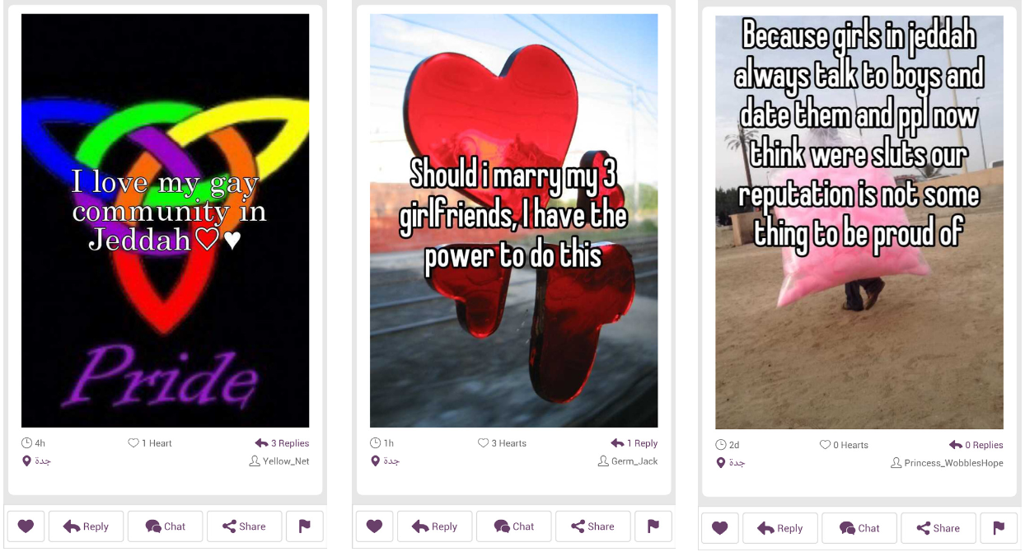

Image Source: Whisper App @Yellow_Net

A similar pattern is reflected online where users are seemingly silent but are actually in constant movement searching and replatforming on to the next latest app that purportedly offers more privacy until it gets discovered and taken down by the Saudi CITC (Communications and Information Technology Commission) and the cycle repeats. ‘I love my gay community in Jeddah’, says a post found on Whisper in 2012, an app that gained quite a bit of traction due to its feature of anonymously posting text and image. Snapchat followed, gaining popularity soon after, in 2015. Most recently, Saudi users have replatformed onto Clubhouse, hosting rooms under the topics of ‘Racism in Saudi Arabia’, ‘Legalization of Alcohol in Saudi Arabia’ and ‘Stories of Surveillance under MBS’ only to find pro-government Saudi Twitter accounts taking screenshots and recording conversations from among those in the room, noting down their identities, threatening and shaming everyone involved.[8] The fast pace of crackdowns on apps makes replatforming a short-lived strategy without the ability to gain much traction.

So not only does replatforming lessen reach, but it also subjects users to harassment and possible detainment. Butwhat triggers certain posts to be flagged? And what types of posts manage to stay under the radar? IP Blocking, Keyword filtering, DNS poisoning, and manual enforcement are just some methods the state uses to flag content. Tweeting or retweeting any content that directly calls out the government, the ruling family, or religion is typically flagged within 24 hours.

## The Clapback

Whilst scrolling through my TikTok explore page I find a deep fake of King Salman singing along to Ping Fong’s Baby Shark:it dawns on me that the type of content that doesn’t get taken down usually comes in the form of memes. Authorship is one of the reasons memes don’t get taken down, as remix culture allows for memes to shapeshift and adapt to different narratives. American blogger and internet activist Ethan Zuckerman formed what is known as the ‘Cute Cat Theory’ where he creates a dichotomy between users who share pictures of their cats and those who engage in political activism. In many ways, both messages leverage the same tools, but they differ intrinsically stating that ‘[Web 1.0] as designed by Tim Berners-Lee at CERN, was intended to let physicists share research findings online…With Web 2.0, the web became a space for the creation and dissemination of amateur content. The contemporary Internet was designed, in no small part, for the dissemination of cute pictures of cats.’[9] In her book *Memes to Movements*, An Xiao Mina further elaborates on the Cute Cat theory by claiming that ‘if you are trying to censor activist messages, you will inevitably censor the same internet that is being used to spread amateur media, the things which people enjoy and you will inevitably upset more people than you originally intended.’[10]

The cute cat theory draws parallels with how memes in Saudi Arabia have been used by different fringe subcultures as forms of critique. Below are examples of memes that critiqued the former societal male guardianship system (a law abolished in August 2019 that once forced women to seek approval from their male guardians to travel, get married or divorced). See also memes made by the Saudi illegal immigrant community shedding light on police raids and most recently memes criticizing the Saudi Covid 19 contact tracing app and lockdown measures. All these are highly critical topics that would have been flagged had they been framed in the form of tweets or interviews, but dressed in the vernacular of memes they seem to be dismissed by state. Michel Foucault touches upon the

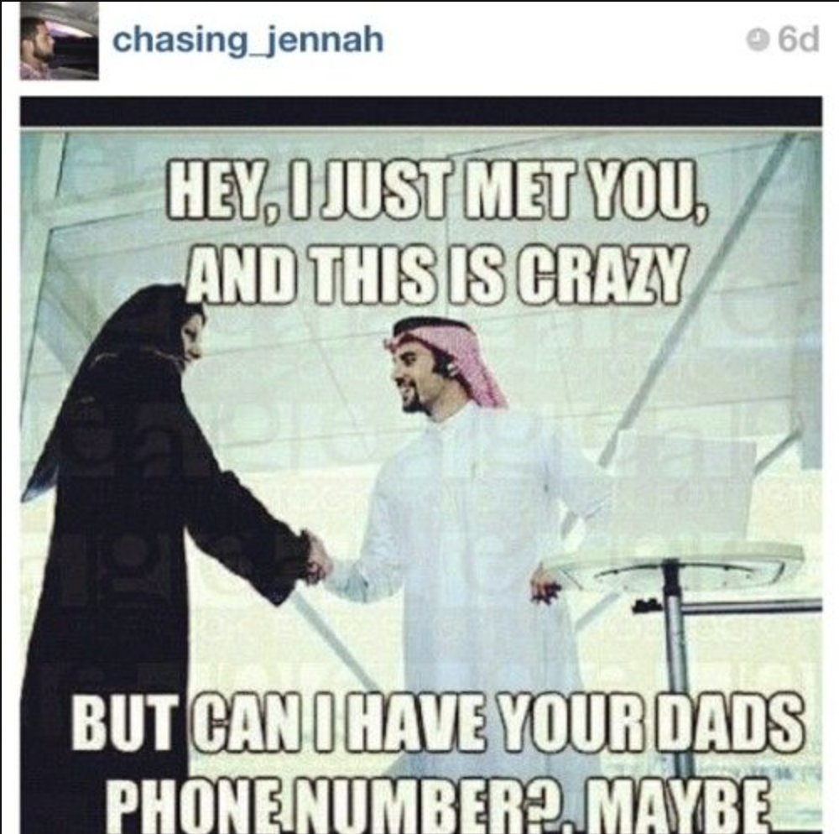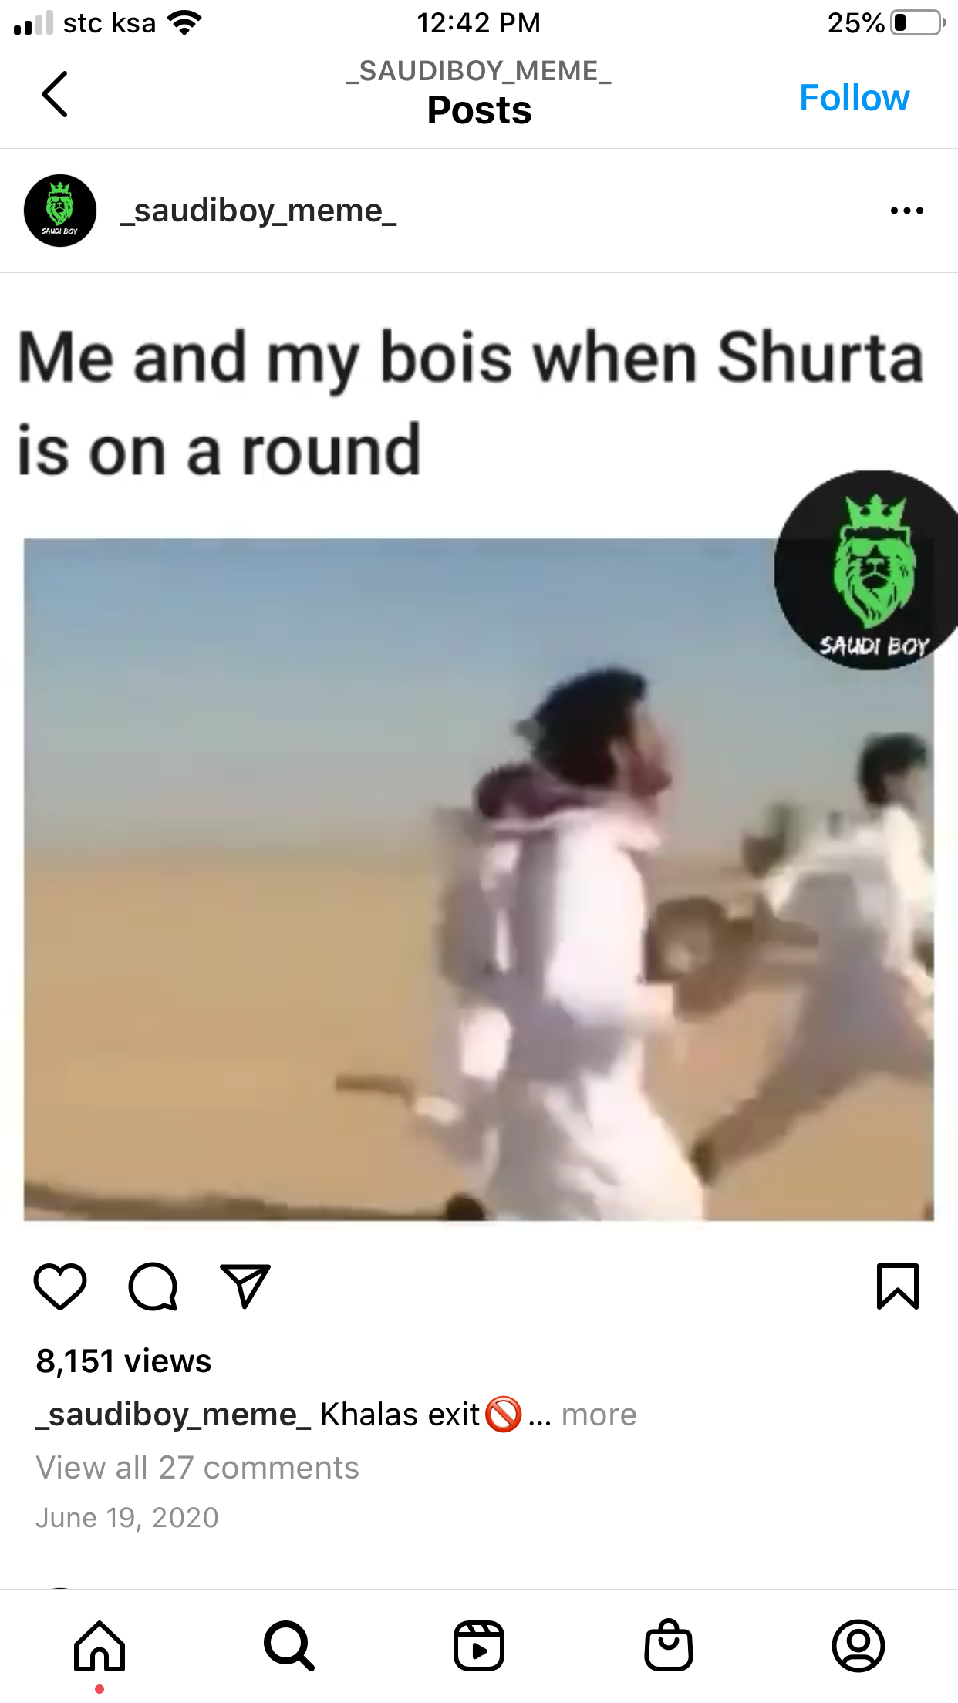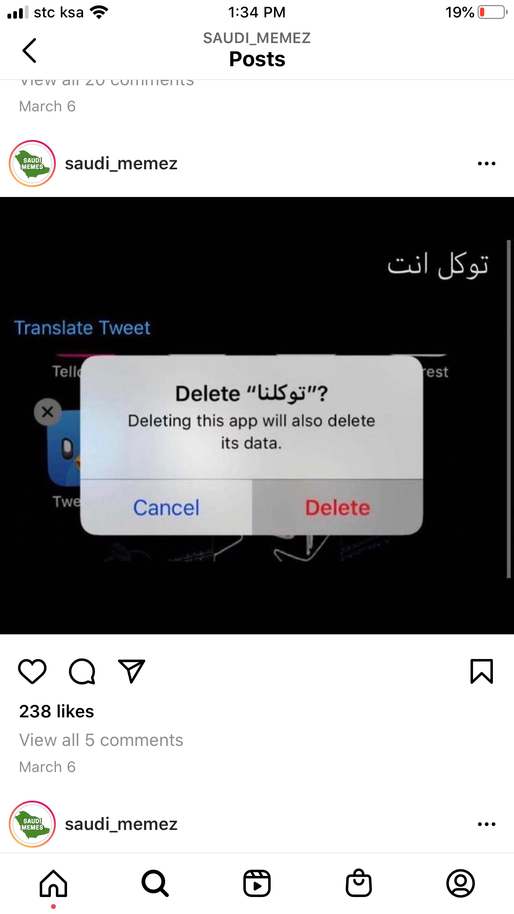

Example of a meme on Male Guardianship

Source: Twitter @chasing_jennah

Meme commenting on police raid during the nationwide crackdown on illegal immigrants

Source: Instagram @_saudiboy_meme_

The covid19 contact tracing app is called Tawakalna which roughly translates to God be with you. This meme deletes the app ands write to it God be with you

Source: Twitters @saudi_memez

notion of ‘disqualified knowledges’ when he writes that ‘It is through the re-appearance of this knowledge, of the local popular knowledges, the disqualified knowledges, that criticism performs its work.’[11]

This underlies that idea that the distance between the very serious and very silly is quite small. The epistemology of nonsense has been used and reused many times by various internet sub communities as a key method of criticism. ‘Of course we make nonsense,’ states @InRealityADream, a Tumblr account that describes the creation of memes as 'neo-Dadaist,’ an echo of the early-20th-century art movement that deliberately abandoned logic and coherence as a statement on the effort it takes to make sense in a world without sense.[12] The Tumblr post that popularized this term on the platform specifically describes memes filled with nonsense, obscure cultural references, and comments about suffering depression, as an inescapable response to the socioeconomic conditions young people are subject to in the 2010s.[13]

American far right blogger, Curtis Yarvin (aka Mencius Moldbug) also looks at the notion of nonsense as a powerful way to spread disinformation, stating that, ‘in many ways nonsense is a more effective organizing tool than the truth. Anyone can believe in the truth. To believe in nonsense is an unforgeable demonstration of loyalty. It serves as a political uniform.’[14]

I’d argue that non-sensical memes within the context of Saudi Arabia prove to be effective due to the fact that they are a) nonsensical and b) do not directly address the state, the royal establishment or the religion as stated in the Anti-terrorism law. Instead, they are dressed in the visual vernacular of internet memes, and thus generally disregarded as trolls being a nuisance, with little to no ramifications other than your account being taken down.

## The Instant Meme Noise Generator

Some of the insults coded into the randomized insult generator

Source: Saeeda Saeed

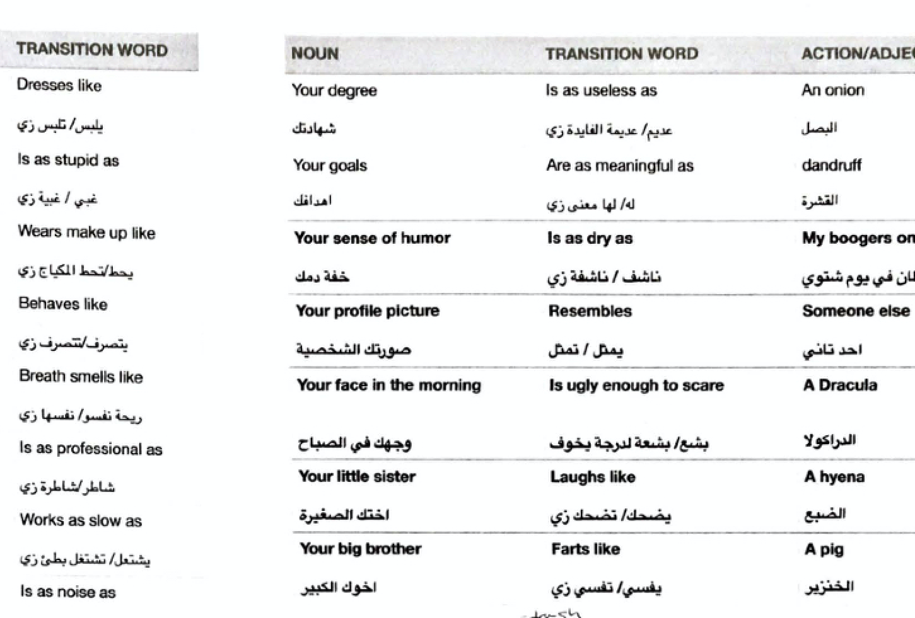

A study titled ‘Dissecting the Meme magic: Understanding Indicators of Virality in Meme Images’ found that memes that trigger high arousal emotions, both positive and negative, such as anger, anxiety, exhilaration, are more like to be shared than low arousal emotions like sadness or contentment.[15] Twitter was once deemed the Saudi congress, a space that was ours in which to discuss, share and vent. But with the platform’s saturation by state surveillance, having no outlet to vent and an overall feeling of helplessness in terms of gaining accountability, I chose to make nonsensical insults aimed at Saudi’s state-run media accounts. Inspired by Brian Gysin & William S. Burough’s cut-up method, I started out by developing a randomized insult generator that constructed sentences which made no particular sense, but assembled together bore the tone of an offensive insult.

I then verbalized the insults by creating voice tracks because in my perspective insults aren't insults until they are verbalized in our mother tongue. During this period, I watched a lot of ASMR keyboard videos and came across a gigantic key cap which looked incredibly satisfying to press and so I ordered it. As soon as the package arrived, I had all the components necessary to build the structure of my game. This is how it worked:

The Instant Meme Noise Generator consisted of pressing one satisfyingly large button for a total of 4 rounds; each round randomly generated insults with the final round tagging one of the Top 10 State run Media accounts and directly uploading the sentence on to Twitter in real time. (In order to play log onto on to <https://insultgenerator.club/> )

An example randomly generated Insult:

[round 1] YOUR MOTHER

[round 2] IS UGLY ENOUGH TO SCARE

[round 3] MOULDED CHEESE

[round 4] TAG STATE MEDIA ACCOUNT[final round ] UPLOAD TO TWITTER

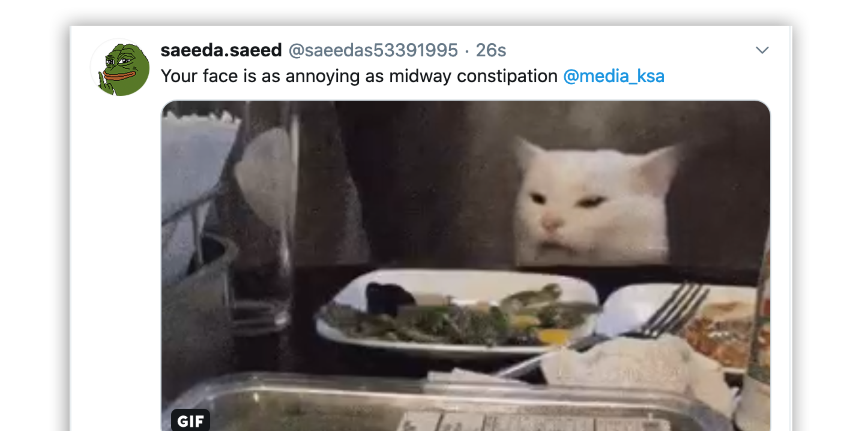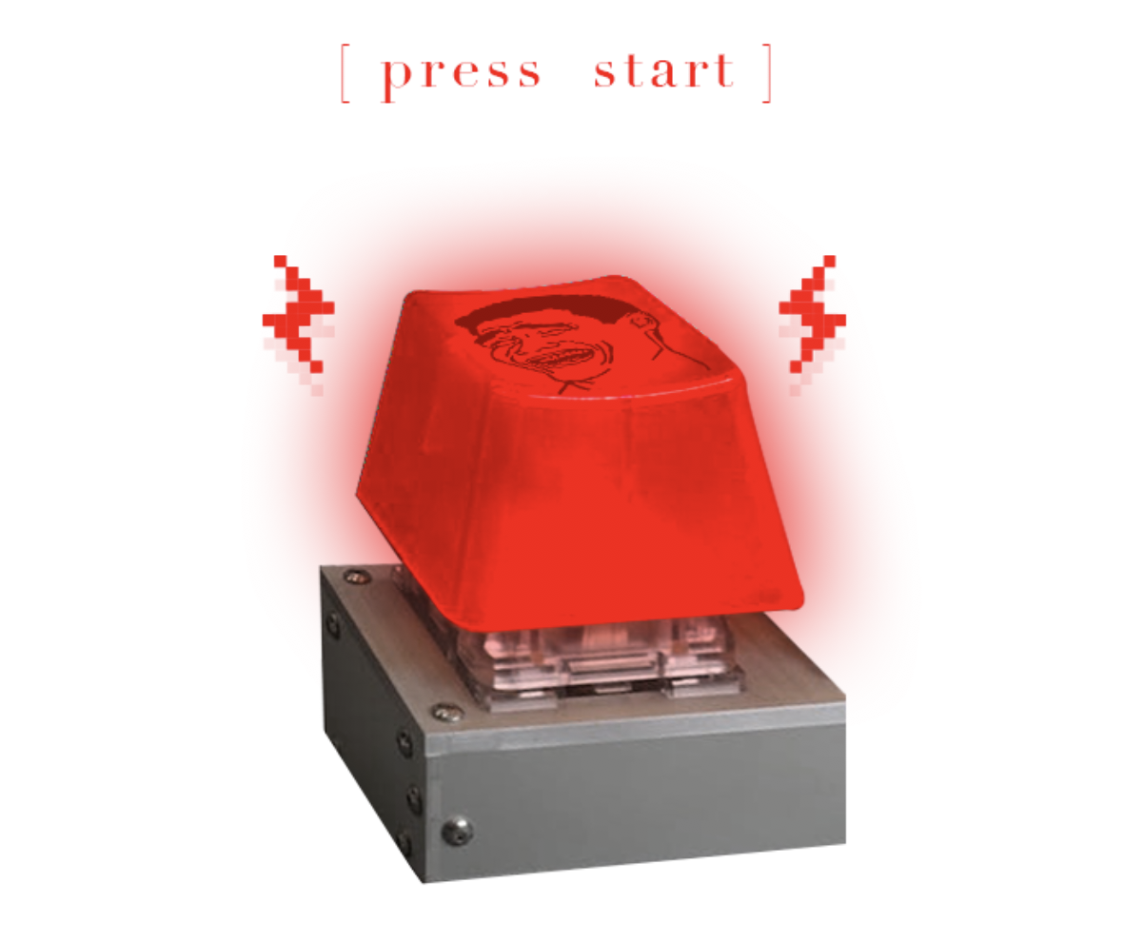

Gigantic key cap from Novel Keys: Big Switch Series. Source: Saeeda Saeed

An example of a nonsensical insult generated post on Twitter. Source: Saeeda Saeed

Now I that I had the mechanism of the game, I needed to find out when and which accounts I should target, and what was the most optimal way to post and drown out official tweets.

## Discovering alternative Counterposting Strategies

In order to develop counterposting strategies, it was crucial to understand the infrastructure of the current Saudi cyberspace, focusing on Twitter as the primary platform. This was done by closely monitoring and gathering the social media metrics of the top 30 state run accounts on Twitter over a three-month period. The task included the daily logging of the following metrics: the frequency and timings of posts, average response times, language, conversion rate, and sentiment analysis. Patterns in the data helped determine potential design opportunities to counter post alternative narratives to that of the state. Below are a few of the findings:

* Peak posting times for Ministries & Government entities is between 0900-0500 as opposed to high-powered individuals who post most frequently between 2300-0400. These time-frames act as an indicator for optimal times to counterpost or generate noise to drown out official tweets.
* English state-run accounts were set up post 2017 as a part of the state’s ‘rebranding’ campaign in the hopes of opening up Saudi tourism and shifting international perception. The data gathered from sentiment analysis shows that this plan backfired since accounts in English were far more susceptible to criticism & negative sentiment from an international audience mostly demanding accountability for the murder and arrests of journalists and activists.
* Twitter state run accounts with low average response times indicate that they are not as heavily monitored and could work as potential spaces to post alternative narratives.

Now that I knew when and which accounts to counterpost, I could finally start playing. The first week of trial posts came to a halt with a notification from Twitter stating, ‘We’ve temporarily suspended some of your account features. Your account appears to have exhibited unusual behavior violating Twitter rules. We may suspend an account if it has been reported to us as violating our rules surrounding abuse.’ Funnily enough, to me, this was an indicator that my counter-tweets where clearly working, as it seemed to have offended/triggered enough state-run accounts to report me to Twitter. I then proceeded to set up a number of backup Twitter developer accounts in preparation for the open studio exhibition of the art residency I had attended in the Netherlands. The expected footfall of the exhibition was about 3000 visitors over the course of three days. The Instant Meme Noise Generator was installed in a dark-lit room with a giant blinking red button tempting visitors to interact and play the role of my personal troll army. The installation featured two screens: the interface of the Instant Meme Noise Generator and a live Twitter feed showing the meme insults being uploaded in real time. Over the course of three days, small crowds of visitors gathered around the game giggling in anticipation, sharing laughs as the generator completed the insult. I recall a conversation between two teenage visitors: ‘Your big brother is ugly enough to scare my boogers on a wintery day @Media_KSA! this is hilarious but wait, did we just assist the artist in insulting the Saudi state?’ The other teenage visitor responds, ‘well if it’s this satisfying to play; I’d be happy do so! C’mon one more round!’ Other responses were slightly more hesitant and cautious, but many felt more inclined to engage upon seeing others interact with the generator.

Over the next two weeks, I continued to play with the Instant Meme Noise Generator, and I was able to measure the impact these nonsensical tweets had. I was initially discouraged upon seeing that there were hardly any retweets, however upon reviewing the analytics of just one of my twitter accounts, I found that each of the top 10 State run media accounts generated between 700-3000 impressions per tweet and in a day that meant up to 600,000 impressions. Impressions on Twitter indicate a total tally of all the times the Tweet has been seen, appearing on a user’s timeline after being liked or commented on. On an average day where I played 200 rounds of the game, I would generate anywhere between 1.4 and 3million impressions. Now imagine if I had used the same method as the state and mobilized an ‘electronic army' who were each tasked to play the game as a 9-5 job; the numbers would multiply significantly and collectively generate a significant amount of alternative noise. An Xiao Mina describes a ‘contest of memes’ in which these seemingly opposing movements are learning from and co-opting each other. They are borrowing each other’s techniques because they are learning how to influence society. ‘We have entered a new world of memetic contention, one where meme culture has become as much a tool for those in power as it has for those seeking to challenge it. Movements of hate have embraced this culture as much as movements of justice.’[16]

## References

Bruenig, Elizabeth. “Why Is Millennial Humor so Weird?.” *Washington Post,* August 11, 2017. https://www.washingtonpost.com%2foutlook%2fwhy-is-millennial-humor-so-weird%2f2017%2f08%2f11%2f64af9cae-7dd5-11e7-83c7-5bd5460f0d7e_story.html.

Burton, Julian. “Look at Us, We Have Anxiety: Youth, Memes, and the Power of Online Cultural Politics.” *Journal of Childhood Studies* 44, no. 3 (2019): 3-17.

Freedom House. “Saudi Arabia: Freedom on the Net 2020 Country Report.” Accessed May, 2021. <https://freedomhouse.org/country/saudi-arabia/freedom-net/2020>.

Foucault, Michel. *Power.* Edited by James D. Faubion, translated by Robert Hurley. The New Press, 2001.

General Authority for Statistics. “The General Authority for Statistics (GASTAT) Releases ‘Saudi Youth in Numbers’ Report for the World Youth Day 2020.” Accessed May 2021. <https://www.stats.gov.sa/en/news/397>.

Hope, Bradley and Justin Scheck. “A Saudi Prince's Attempt to Silence Critics on Twitter.” *Wired*, September 1, 2020. <https://www.wired.com/story/mohammed-bin-salman-twitter-investigation/>.

Jones, Marc Owen. “Clubhouse: A New Avenue of Free Speech, or Yet Another Tool of Repression?,” *Middle East Eye*.” March 4, 2011. <https://www.middleeasteye.net/opinion/clubhouse-free-speech-repression-arab-authoritarians-surveillance>.

Kirchgaessner, Stephanie. “Saudi Heir Complicit in Khashoggi Murder, US Assessment Reportedly Finds.” *The Guardian,* February 25, 2021. <https://www.theguardian.com/world/2021/feb/24/jamal-khashoggi-murder-us-report-saudi-arabia-mbs-king-salman-complicit>.

Laboria Cuboniks. *The Xenofeminist Manifesto: A Politics for Alienation.* Verso, 2018.

Ling, Chen et. al. “Dissecting the Meme Magic: Understanding Indicators of Virality in Image Memes.” *Arxiv* *Preprint,* January 16, 2021. https://arxiv.org/pdf/2101.06535.pdf.

Moldbug, Mencius. “An Open Letter to Open-Minded Progressives – Chapter 4: Dr Johnson’s Hypothesis.” Unqualified Reservations, May 8, 2008, https://www.unqualified-reservations.org/2008/05/ol4-dr-johnsons-hypothesis/.

Makiya, Kanan. *The Monument.* Berkeley: University of California Press, 2004.

Nation Guetta Worldwide, “David Guetta - Ash Salman (Live @ MDL Beast Festival 2019).” YouTube video, December 23, 2019. https://youtu.be/6Yjq1v3quZA.

Mina, An Xiao. *Memes to Movements: How the World's Most Viral Media is Changing Social Protest and Power.* Boston: Beacon Press, 2019.

Zuckerman, Ethan. *Mistrust: Why Losing Faith in Institutions Provides the Tools to Transform Them.* New York: W. W. Norton & Co, 2021.

1. Nation Guetta Worldwide, “David Guetta - Ash Salman (Live @ MDL Beast Festival 2019),” YouTube video, December 23, 2019, https://youtu.be/6Yjq1v3quZA.
2. “The General Authority for Statistics (GASTAT) Releases ‘Saudi Youth in Numbers’ Report for the World Youth Day 2020,” General Authority for Statistics, Accessed May 2021, https://www.stats.gov.sa/en/news/397.
3. Bradley Hope and Justin Scheck, “A Saudi Prince's Attempt to Silence Critics on Twitter,” *Wired*, September 1, 2020, https://www.wired.com/story/mohammed-bin-salman-twitter-investigation/.
4. “Saudi Arabia: Freedom on the Net 2020 Country Report,” Freedom House, 2020, https://freedomhouse.org/country/saudi-arabia/freedom-net/2020
5. Stephanie Kirchgaessner, “Saudi Heir Complicit in Khashoggi Murder, US Assessment Reportedly Finds,” *The Guardian,* February 25, 2021, https://www.theguardian.com/world/2021/feb/24/jamal-khashoggi-murder-us-report-saudi-arabia-mbs-king-salman-complicit.
6. Laboria Cuboniks, *The Xenofeminist Manifesto: A Politics for Alienation* (Verso, 2018), 0x0C.
7. Kanan Makiya, *The Monument* (Berkeley: University of California Press, 2004).
8. Marc Owen Jones, “Clubhouse: A New Avenue of Free Speech, or Yet Another Tool of Repression?,” *Middle East Eye*, March 4, 2011, https://www.middleeasteye.net/opinion/clubhouse-free-speech-repression-arab-authoritarians-surveillance.
9. Ethan Zuckerman, *Mistrust: Why Losing Faith in Institutions Provides the Tools to Transform Them* (New York: W. W. Norton & Co, 2021).
10. An Xiao Mina. *Memes to Movements: How the World's Most Viral Media is Changing Social Protest and Power* (Boston: Beacon Press, 2019).
11. Michel Foucault, *Power,* ed. James D. Faubion, trans. Robert Hurley (The New Press, 2001), 82
12. Elizabeth Bruenig, “Why Is Millennial Humor so Weird?,” *Washington Post,* August 11, 2017, https://www.washingtonpost.com%2foutlook%2fwhy-is-millennial-humor-so-weird%2f2017%2f08%2f11%2f64af9cae-7dd5-11e7-83c7-5bd5460f0d7e_story.html.
13. Julian Burton, “Look at Us, We Have Anxiety: Youth, Memes, and the Power of Online Cultural Politics,” *Journal of Childhood Studies* 44, no. 3 (2019): 3-17.
14. Mencius Moldbug, “An Open Letter to Open-Minded Progressives – Chapter 4: Dr Johnson’s Hypothesis,” Unqualified Reservations, May 8, 2008, https://www.unqualified-reservations.org/2008/05/ol4-dr-johnsons-hypothesis/.
15. Ling, Chen et al., “Dissecting the Meme Magic: Understanding Indicators of Virality in Image Memes,” *Arxiv* *Preprint,* January 16, 2021, https://arxiv.org/pdf/2101.06535.pdf.
16. Mina, *Memes to Movements.* 